**New Build Information**

In our last discussion with Dr. Kim, he pointed out major problems with our existing database design. Furthermore, there has been a discussion between me and Louis since long ago regarding the inefficiency doing price/feature analysis separately. Seeing the needs now overcome hassles to rebuild the system, we have made a new build with database changes to support easier team distribution, and software changes to support analysis both price and feature at the same time (consecutively). This approach reduces number of distributed dataset by half (each dataset now contains both price and feature information), and increases efficiency in collecting information (or if it does not, please reply me with feedback).

# Database

We have changed the Database engine to MyISAM, which technically supports importing/exporting database by “copy and paste”. In addition, MyISAM supports better partitioning (so now we can split the table into 5 parts while crawling, each of which will later on be assigned respectively to each of you to analyze). The MyISAM database design was supposed to get approval from Dr. Kim, yet he was to go back to Korea unexpectedly. I believe that if there is any major issue, he will inform us asap.

The following section describes one trivial way to import dataset to your local database (please note that this approach however is not recommended by MySQL man page). In the event of unsuccessful import, please inform me through whatsapp/email. Please always take extra steps to ensure your previous works are backup properly.

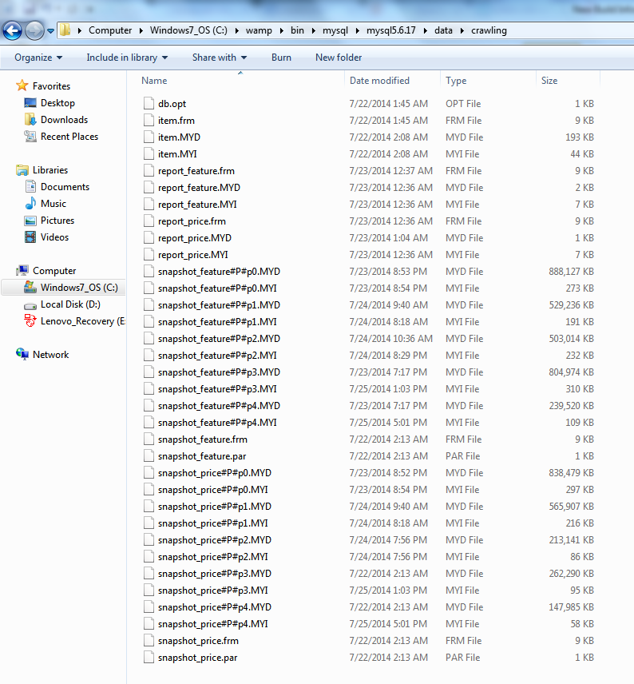

As you can see here, this folder reflects the structure of our new database. We have 5 tables naming item, snapshot_feature, snapshot_price, report_feature, report_price. Note that tables snapshot_feature and snapshot_price are partitioned into 5 parts based on itemID range, each of which will be assigned as your duty respectively. In the event that crawling speed becomes too slow, I will still have the capability to distribute a part of snapshot_* tables for you to analyze. For simplicity, we will do it the simple way this time: I have done crawling Yan Rong’s list, zipped it to a folder named YRList_RENAME_TO_crawling.zip. What you should do is described as following:

* Back up all of your previous work using PhpMyAdmin export.
* Turn off warmserver. Make sure mysqld.exe and mysql*.* are terminated from Task Manager.
* Unzip the folder to this directory wamp/bin/mysql/mysql5.6.37/data/. Rename the (zipped) folder to crawling.
* Start wampserver. Login to localhost and make sure database crawling exists.
* You are now ready to boot up GUI to do your analysis task.

# GUI

We have recently introduced a slide-bar to the GUI in order to support analyzing price and feature of a product more efficiently. The following section gives an idea of how this should be used.

<To be updated>